Middleware Data view create utlility will create the view in middleware data as par set CBS data in config file.

Copy the middlewareview create utility in saperate folder.

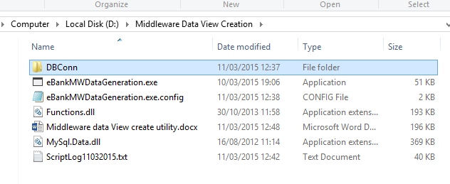

Create the CBSMWdbconn of middleware data by dbconn exe

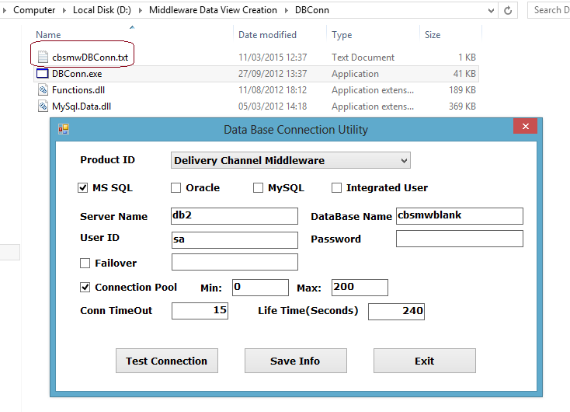

Set middleware data path in config file.

Set CBS data path in config file.plz mention database name with dbserver name.

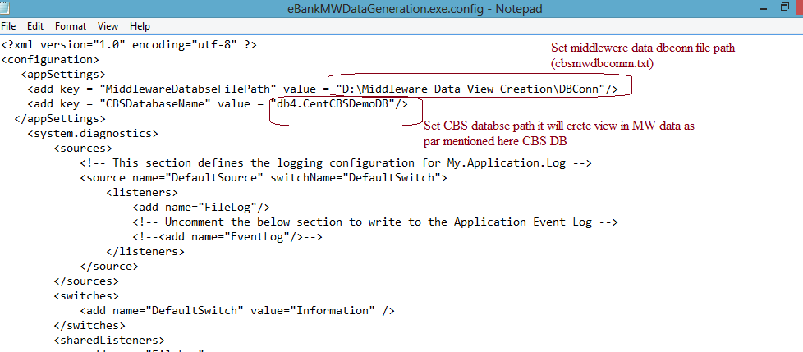

Then run ebankMWdatageneration exe. It will show middlware data and cbs data name as par set in config file.

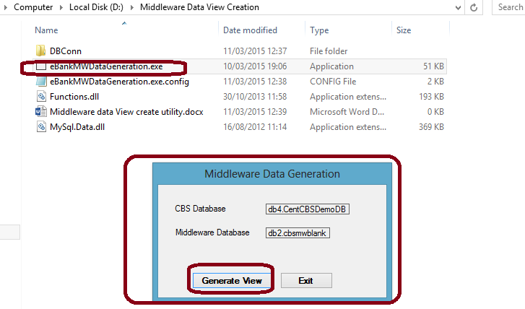

Press on generate view, it will start to create require view In middleware data as par CBS data.

